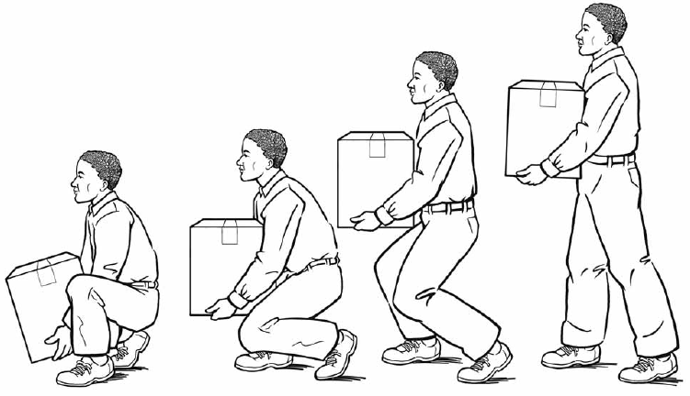
Lift with Your Legs
Not with Your Back

Safety First at [Company Name]

