NOTICE

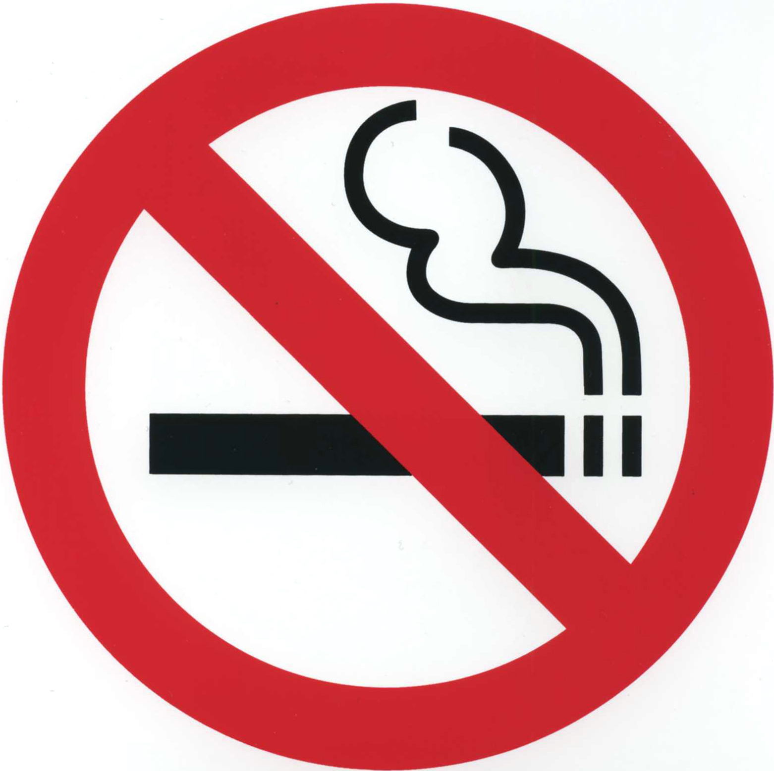

NO

SMOKING

