DANGER

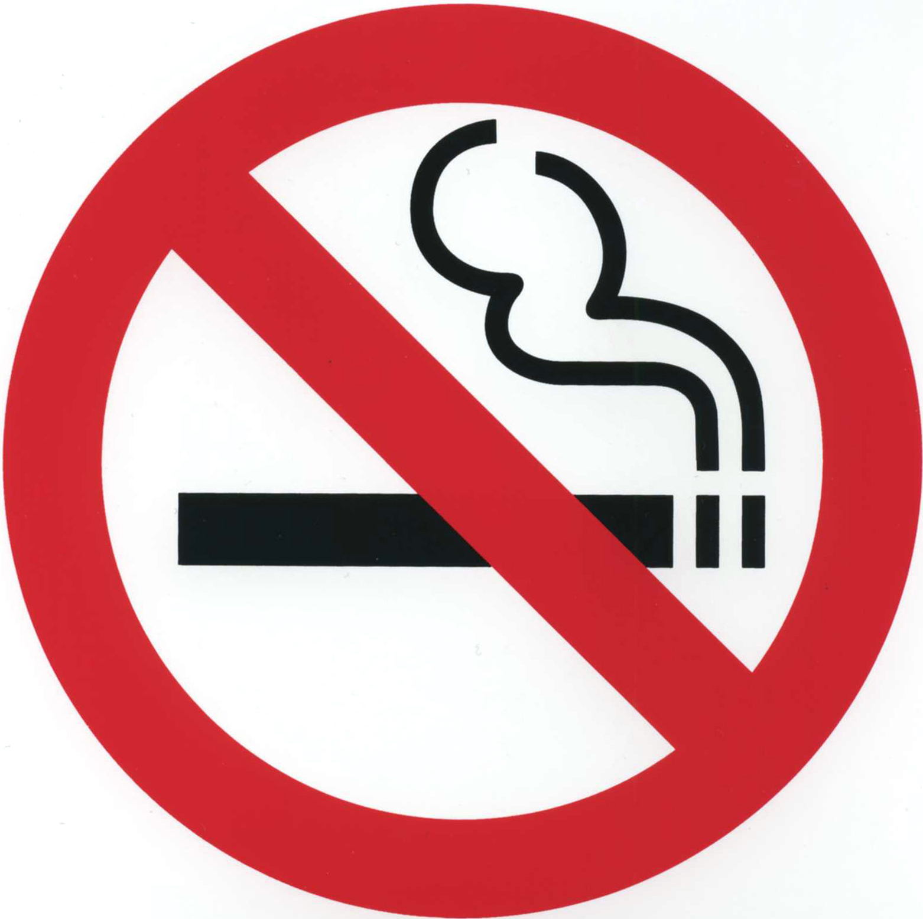

NO SMOKING OR OPEN FLAMES WITHIN 50 FEET

